Please Remember:
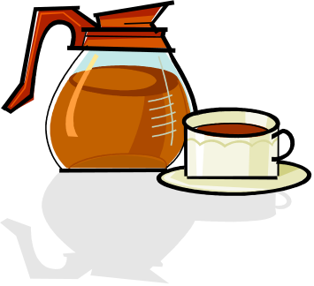
Check the Coffee Pot
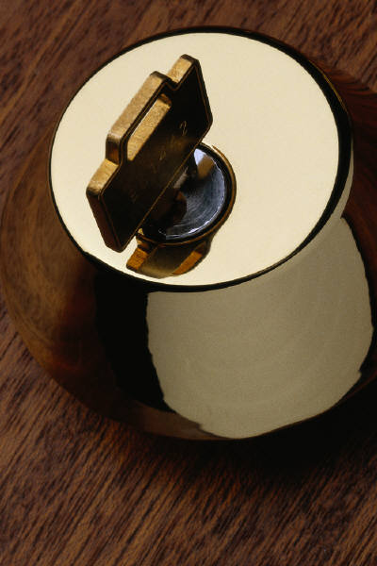
Lock the Door!

Last thing we want is our coffee stolen!

